Design Concept Report Intake Form

Project Name
Project Identification #

Month, XX, 202X

Design Concept Report Intake Form

Purpose & Process

The Design Concept Report (DCR) Intake Form is a standard form to be completed by an external agency to demonstrate interest in undertaking a project within the City of Houston’s boundaries. It outlines basic information that helps to determine whether the project warrants the DCR process or not. Houston Public Works’ (HPW) Interagency - Planning will determine, based on the external agency’s responses on this form, whether a DCR needs to be undertaken. This form must be completed and submitted to Interagency electronically.

- DCR Needed:
  - All reconstruction projects require a DCR. If it is determined that a DCR is needed, the external agency will work with HPW to create a DCR for the project. The process and details for conducting a DCR will be outlined by the Interagency coordinator for your project. A DCR will typically be needed for a full roadway reconstruction project or a drainage project.
- DCR Not Needed or Lite DCR:
  - Projects that may not need a DCR include resurfacing, mill overlay, panel replacement, sidewalk panel replacement, or other surface projects of that nature. If it is determined that a DCR is not needed, the following process will be followed:
    - A collation of all previous and current documentation, design concepts related and relevant to the project will be presented to Interagency coordinator for review. A cover letter clearly outlining the project need, limits, brief history, proposed improvements, and any other relevant information should be included.
    - Interagency coordinator will review and process the information and request additional information, if needed.
    - Interagency coordinator will notify external agency in writing of approval and project will continue with development.
- Lite DCR includes project that needs minor analysis or documentation by HPW Service Lines. Interagency coordinator will notify external agency in writing of the requests.

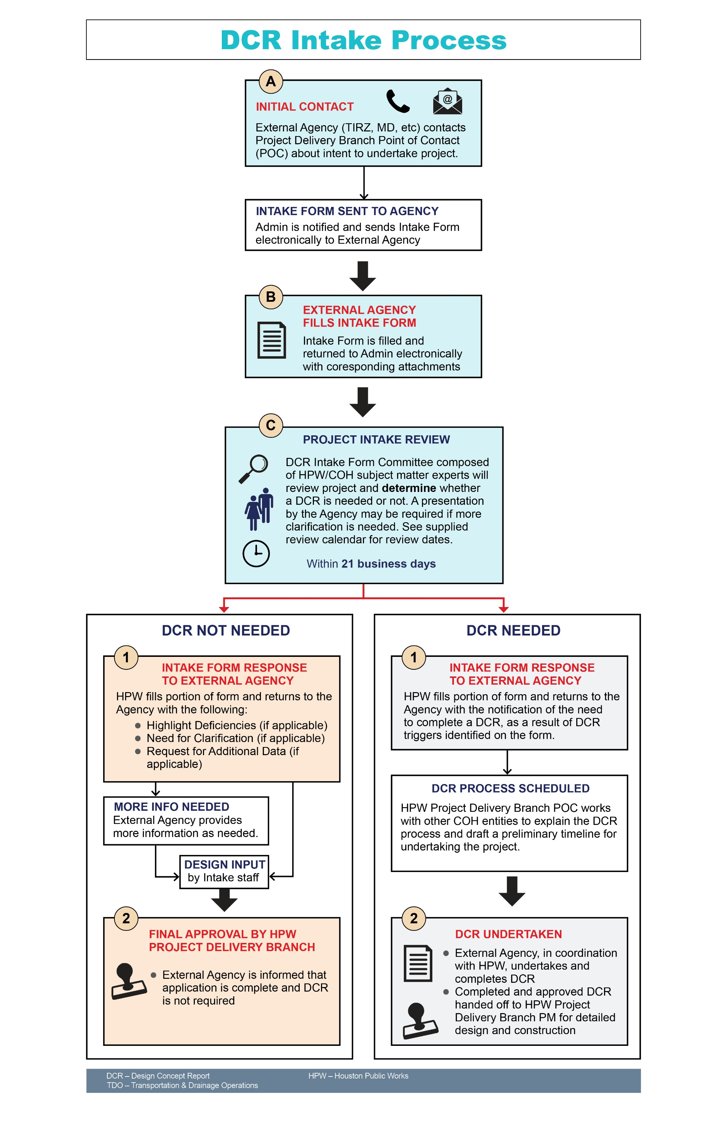

Design Concept Report (DCR) Intake Form

Entity Name:
Project Title/Project ID or WBS Number:
Does this Project only include resurfacing, mill overlay, panel replacement, sidewalk panel replacement, or other surface projects of that nature: Yes___ No___
Is it estimated that any real estate right (land ownership / permanent easement / temporary construction easement / crossing permit / letter of no objection) might need to be acquired for this project? Yes___ No___ If Yes, please describe below in Table 1.
Is it likely this project might cause impact to any landowner or tenant by eliminating or modifying their existing property use such as driveway, parking, alley access, landscape, sign, other? Yes___ No___ If Yes, please describe below in Table 1.
Project Need & Purpose:
Project Location and Limits (Attach Map):
New Project: Yes___ No___ If No, please reference previously approve/on-going project
Planned/Expected Date:
- Design:
- Construction:
- Phased Project: Yes___ No___
Source(s) of Funding (TIRZ, Grant, CIP etc.):
TIRZ Budget (Identified in TIRZ CIP Budget): Yes___ No___ If yes, include copy
Planned Maintenance (TIRZ, Management District, COH etc.):

Table 1
Complete table below with information that this project is potentially impact
COMPONENT | EXISTING | PROPOSED | NOTES | HPW COMMENTS  (For City Use Only)
City of Houston Strategies
COH Major Thoroughfare Plan Designation

COH Bike Plan Designation

COH Vision Zero Initiatives:
- COH High Injury Network
- Crash and Safety Factors
- Other
Metro Next Transit Corridor
Resiliency Initiatives
- Green Stormwater Infrastructure Plans
- Other Plans

COMPONENT | EXISTING | PROPOSED | NOTES | HPW COMMENTS
Vehicle Lanes
- Number
- Width
- On-street Parking
- Pavement Type
- Bicycle
Pedestrian Realm/Back of Curb
- Sidewalks
- Crosswalks
- Pedestrian Amenities
- ROW width
- Low Impact Development (LID) Features
Fire Hydrant(s)
Drainage
- Inlets/Storm Sewer
- Open Ditch
Real Estate
- Acquisition Estimate
Land Ownership
Permanent Easement
Temporary Construction Easement
Crossing Permit
Letter Of No Objection
- Existing Use
Elimination / Modification
Submitted By:
EOR/Project Manager/Organization (including name and address):

Email/Phone Number:

Date:

Please submit this form electronically to: InterAgencygroup@houtx.onmicrosoft.com
With subject heading: DCR Intake Form – (Project Name and Agency)

Project Resources:
City of Houston Planning Department:
- Major Thoroughfare Plan Information: MTFP (houstontx.gov)
- Houston Map Viewer (MTFP, Platting Information): Houston Map Viewer (houstontx.gov)
- Vision Zero: Houston Vision Zero (houstontx.gov)
Houston Public Works:
- Build Houston Forward: ReBuild Houston is now Build Houston Forward
- Geolink (Utilities): Geolink (houstontx.gov)

Interagency Contact Information:
Patrick Nguyen, Senior Division Manager Patrick.nguyen@houstontx.gov
Jiada Huang, Engineer, jiada.huang@houstontx.gov
Table 2 (For HPW Use)
Explanation is needed for this Table 2
COH/HPW DEPARTMENT OR SUBJECT MATTER EXPERT | TRIGGERS INVOLVEMENT (Y/N) | COH/HPW DEPARTMENT COMMENTS
Wastewater
Water
Drainage Operations
Street Maintenance
Traffic
Fire Dept
Planning Dept
Real Estate
Other Departments:
- Dept 1
- Dept 2
WBS Number Assigned? ____ Y ____N Number:

Review #1:
Initial COH/HPW Review Meeting Date:
Referred Back to External Agency:
Date:
Comments included in HPW Comments Column in Table 1: Y___N___
Comments included in Table 2: Y___N___
Additional HPW Comments:

