Design Concept Report Intake Form

Project Name
Project Identification #

Month, XX, 202X

Design Concept Report Intake Form

Purpose & Process

The Design Concept Report (DCR) Intake Form is a standard form that is filled by an external agency to demonstrate interest in undertaking a project within the City of Houston’s boundaries. It outlines basic information that helps to determine whether the project warrants the DCR process or not. Houston Public Works’ (HPW) Interagency - Planning will determine, based on the external agency’s responses on this form, whether a DCR needs to be undertaken. This filled Form is supplied to Interagency electronically.

- DCR Needed:
  - All reconstruction projects require a DCR. If it is determined that a DCR is needed, the external agency will work with HPW to create a DCR for the project. The process and details for conducting a DCR will be outlined by the Interagency Service Line of HPW. A DCR will typically be needed for a full roadway reconstruction project or a drainage project.

- DCR Not Needed:
  - Projects that may not need a DCR include resurfacing, mill overlay, panel replacement, sidewalk panel replacement, or other surface projects of that nature. If it is determined that a DCR is not needed, the following process will be followed:
    - A collation of all previous and current documentation and design concepts related and relevant to the project will be presented to Interagency Service Line for review. A cover letter clearly outlining the project need, limits, brief history, proposed improvements, and any other relevant information should be included.
    - Interagency Service Line will review and process the information and request additional information, if needed. This step is not anticipated to exceed 21 business days after submission.
    - Interagency Service Line will notify the external agency of approval of the project and will continue project development.

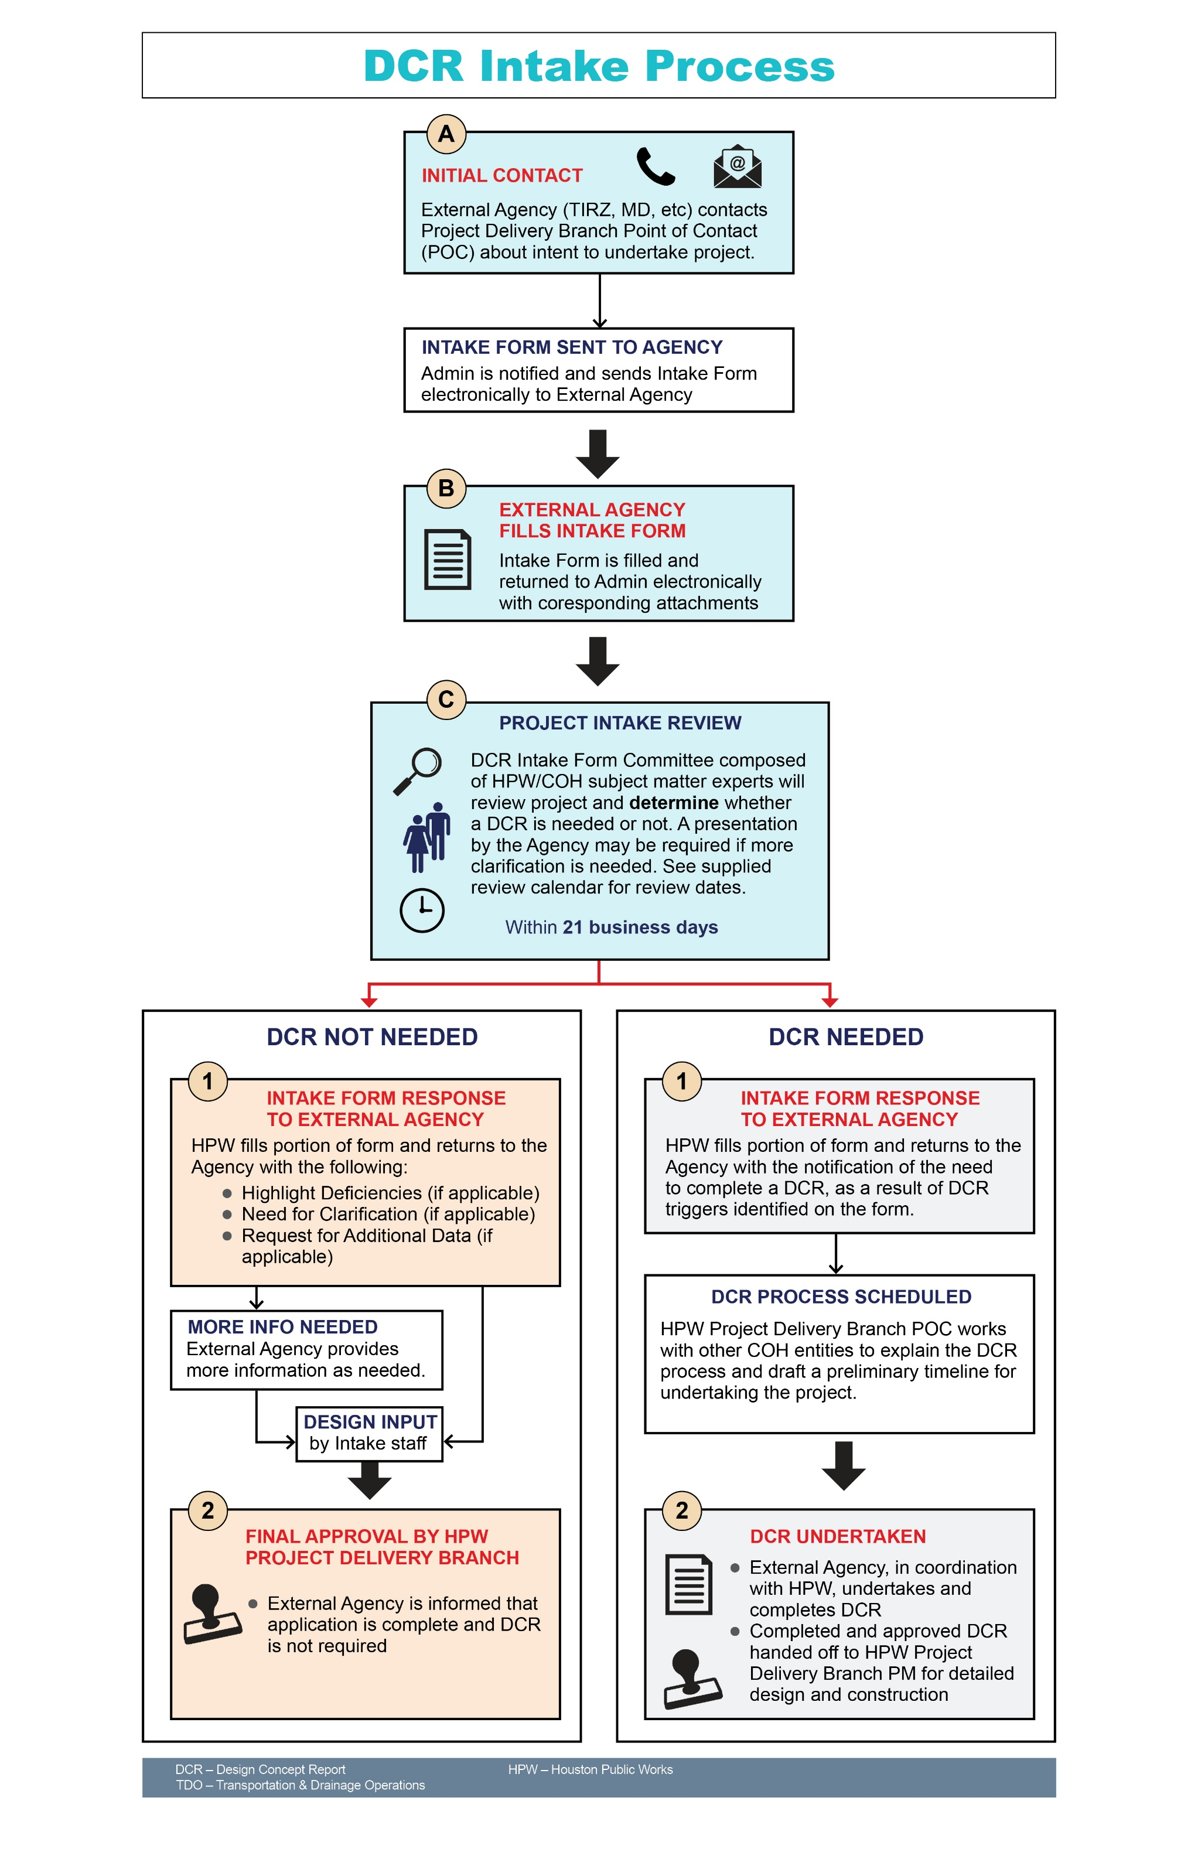

Design Concept Report Intake Form

Entity Name:
Project Title/Project ID or Number:
Project Need & Purpose:
Project Location and Limits (Attach Map):
Planning Project Yes___ No___ Reconstruction Project: Yes___ No___ Rehabilitation Project: Yes___ No___
Planned/Expected Date:
- Design:
- Construction:
- Phased Project: Yes___ No___
Source(s) of Funding (Attach Budget):
Planned Maintenance (TIRZ, Management District, COH etc.):
Table 1
COMPONENT | EXISTING | PROPOSED | NOTES | HPW COMMENTS
City of Houston Strategies
COH Major Thoroughfare Plan Designation

COH Bike Plan Designation

COH Vision Zero Initiatives:
- COH High Injury Network
- Crash and Safety Factors
- Other
METRO Corridor
Resiliency Initiatives
COMPONENT | EXISTING | PROPOSED | NOTES | HPW COMMENTS
Travel Lanes
- Number, Width, Parking, Heavy Trucks
- Bike Plan Designtation
Pedestrian Realm/Back of Curb
- Sidewalks
- Intersection Work
- Pedestrian Amenities
- Real Estate Acquisition
- Power/light poles
EMS Clearance
Drainage
- Inlets/Storm Sewer

- Open Ditch

Submitted By:
Entity/Organization:
By Email, Y___N___ Other:
Date:
Project Resources:
City of Houston Planning Department:
- Major Thoroughfare Plan Information: MTFP (houstontx.gov)
- Houston Map Viewer (MTFP, Platting Information): Houston Map Viewer (houstontx.gov)
- Vision Zero: Houston Vision Zero (houstontx.gov)

Houston Public Works:
- Build Houston Forward: ReBuild Houston is now Build Houston Forward
- Geolink (Utilities): Geolink (houstontx.gov)
Contact Information:
Thomas Kirn, AICP, CFM: DCR Intake Form Administrator, thomas.kirn@houstontx.gov (Primary)
Patrick Nguyen, Division Manager Patrick.nguyen@houstontx.gov (Secondary)
Table 2 (For HPW Use)
COH/HPW DEPARTMENT OR SUBJECT MATTER EXPERT | TRIGGERS INVOLVEMENT (Y/N) | COH/HPW DEPARTMENT COMMENTS
Wastewater
Water
Drainage Operations
Street Maintenance
Traffic
Fire Dept
Planning Dept
Other Departments:
- Dept 1
- Dept 2
WBS Number Assigned? ____ Y ____N Number:

Review #1:
Initial COH/HPW Review Meeting Date:
Referred Back to External Agency:
Date:
By Email, Y___N___ Other:
Additional HPW Comments:

