- You can pay by clicking the link below:

https://www.pdinet.pd.houstontx.gov/ILMS_Online_Permits/default.asp

- You will need to create an account
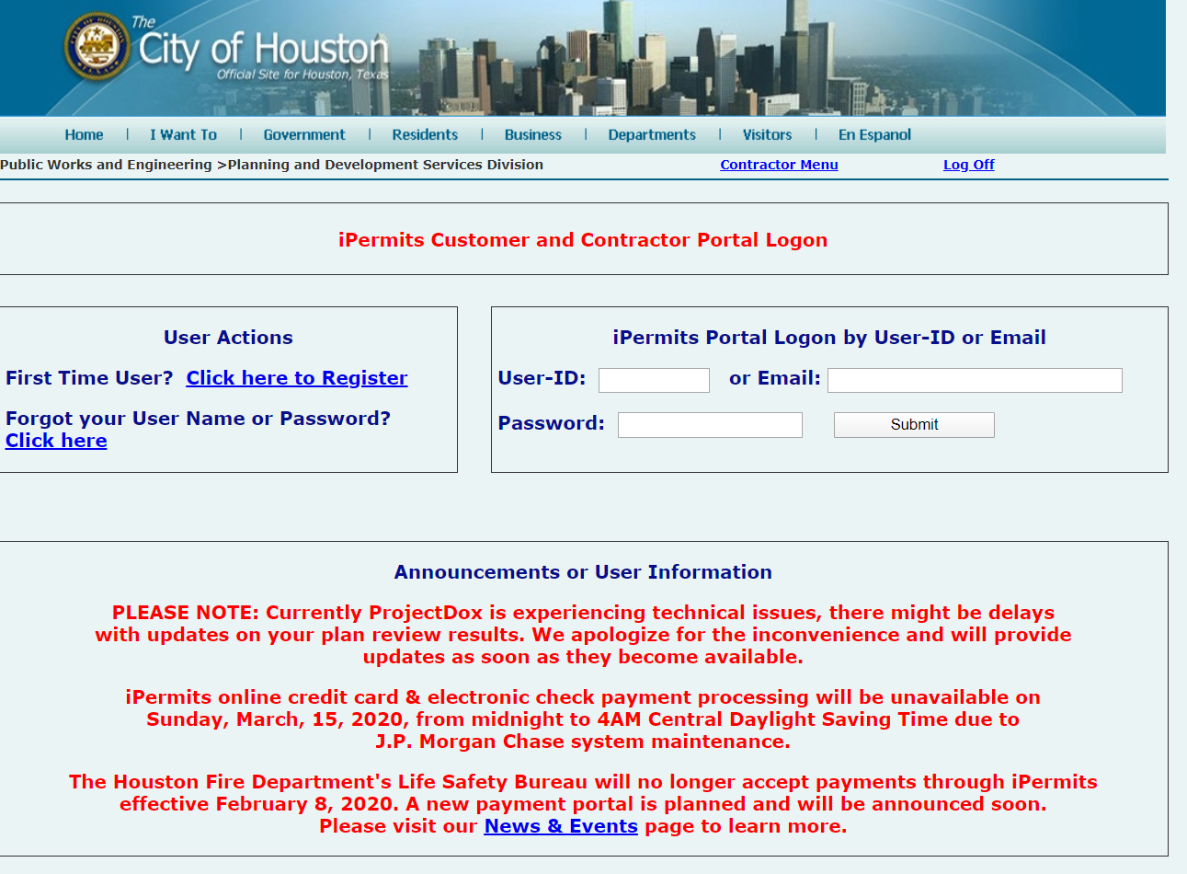
- First time users must register.
-Email will be sent with User Id and Password.
- -Log in to iPermits Account (enter User Name/Password)

- Select contractor Menu (If not automatically routed)
- 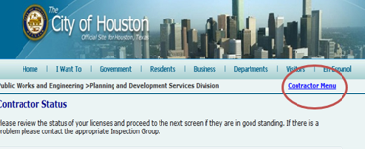

- Select the Option: Pay Houston Permitting Center Shopping cart.

- Enter Shopping Cart number located at the bottom of you POS Transmittal page to the right of the barcode.
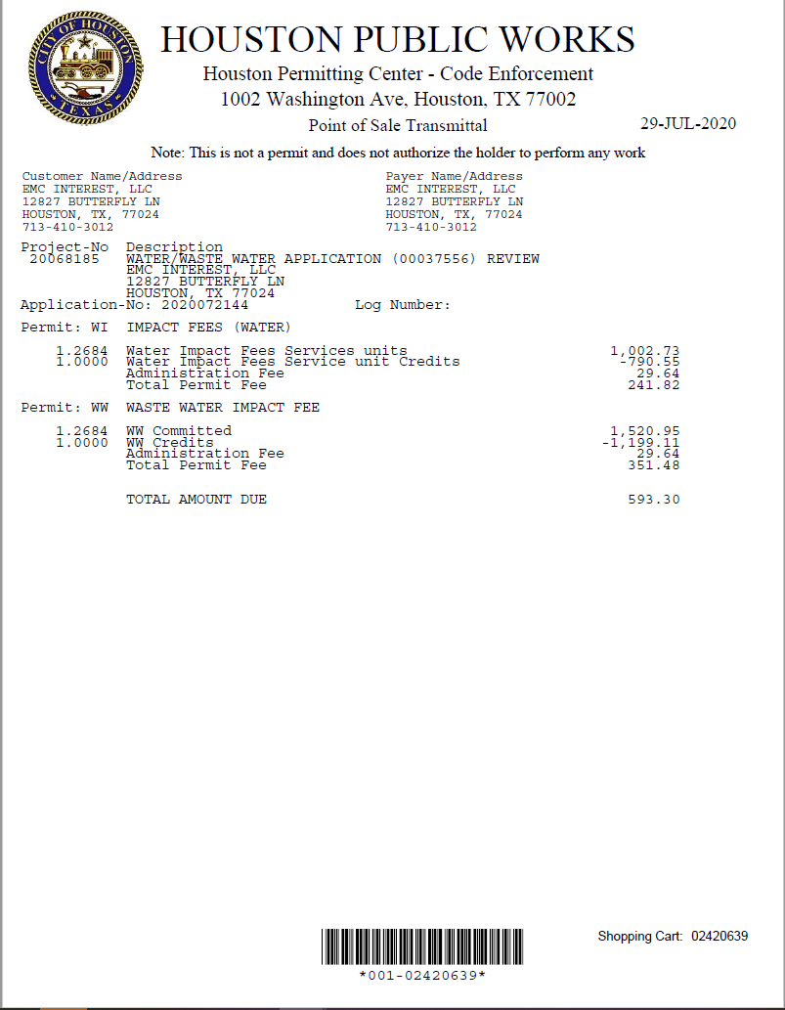

- Proceed to payment.
- Once you are in the payment screen, it is no longer our domain but that of JP Morgan Chase.
- You will need to contact them if you run into any error with processing your payment.

